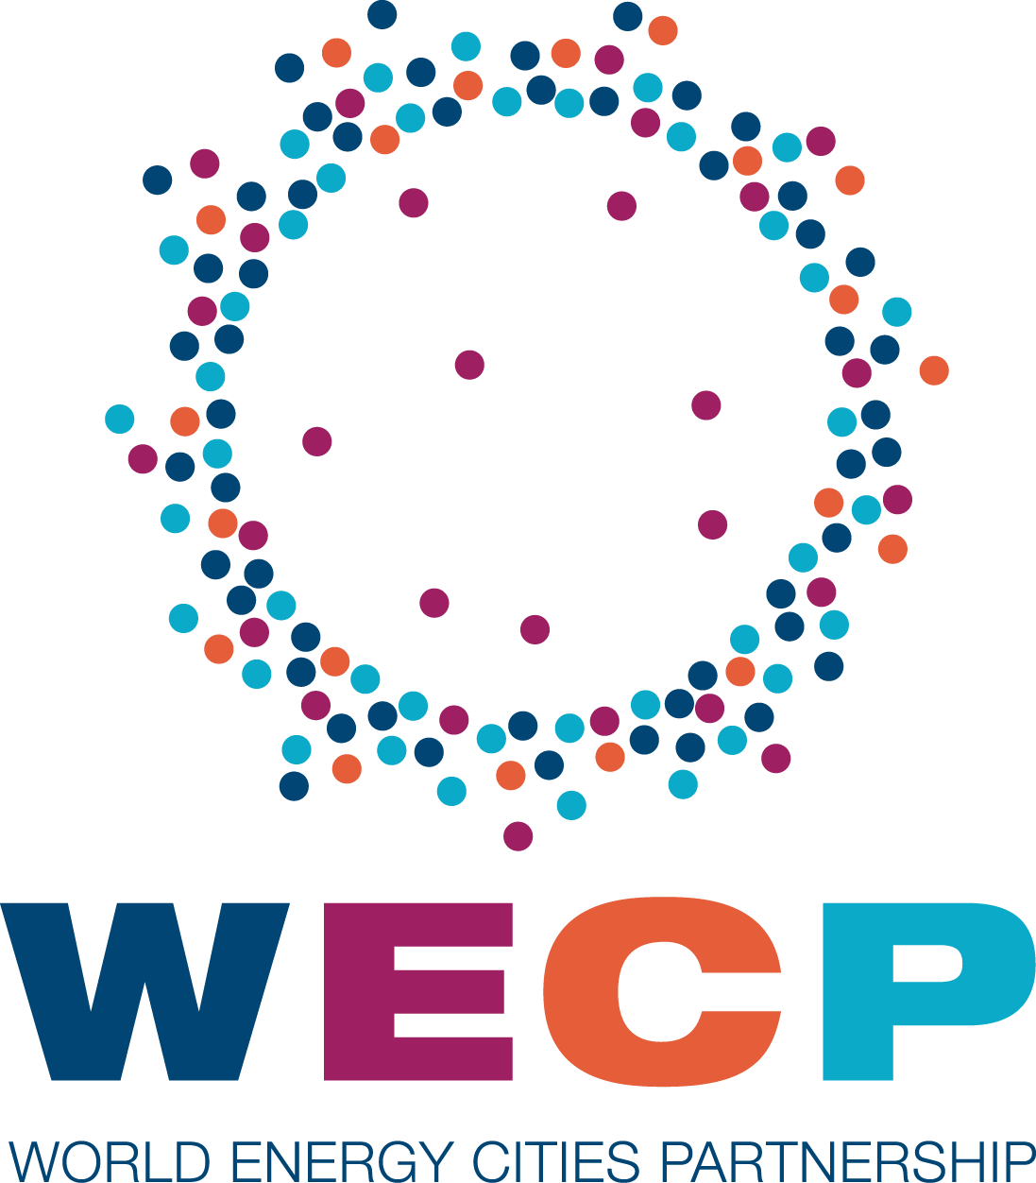
Table of Content
May 5 – May 7, 2019

Agenda of Best Practices Sharing session – Sunday, May 5, 2019…..………………………………….…………….p. 3
Agenda of the Officers Committee meeting – Monday, May 6, 2019…….………………………………….…….p. 4
- Minutes of the October 2018 Annual General Meeting - Officers Committee (Annex 1)
Agenda of the Board of Directors meeting – Tuesday, May 7, 2019………….……………………………...…….p. 5
- Minutes of the October 2018 Annual General Meeting - Board of Directors (Annex 2)
Secretariat Updates
- Strategy – Review and discussion of next steps.
  - Input from the Presidency
- CERAWeek – Review
- Staffing – Comments and plans
Economic Development Committee Report………………...……………………………………………….….…..………...p. 6
Marketing & Communications Committee Report……………….…………..………….…………..…………...…….….p. 7
- Social Media report – Year ending December 31, 2018 (Annex 3)
Education Committee Report………………..……….………………………………..…………………….…………..…….…….p. 8
Environment Committee Report………………..……………………………………………….………….……………..….…….p. 9
Membership Committee Report…………………………………..………….………………….…………….…………..….….p. 10
- Motion to approve the Member Report Card (Annex 4)
- Member Report Card (Annex 5)
- Membership Criteria discussion
- Current Membership Criteria (Annex 6)
Finance Committee Report………………..………………..………………….…..……………………………..………....…….p. 11
- Motion to approve the Unaudited Financial Statements for the Year Ended December 31, 2018 (Annex 7)
- Unaudited Statement of Operations and Balance Sheet for the Year Ended December 31, 2018 (Annex 8)
- Proposed Operating Reserve Policy (Annex 8)
World Energy Cities Partnership
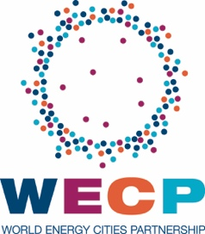
Agenda
Best Practices Sharing Session

05/5/2019 – 2:00 PM – 4:00 PM

City Hall – 901 Bagby St, 4th floor

14:00 – 14:20 Norway Energy Solutions (Stavanger)

14:20 – 14:40 Houston Innovation District (Station Houston)

14:40 – 15:00 Discussion of potential linkages between clusters/innovation hubs.
World Energy Cities Partnership
Agenda
Officers Committee Meeting

05/06/2019 – 2:00 PM – 4:00 PM

Houston Club – 910 Louisiana St, Floor 49

14:00 Arrival

14:05 Welcome – Nancy Phillips, Halifax

14:10 Minutes
- Kuala Lumpur 2018 Annual General Meeting minutes……..……..…..(see Annex 1)

14:15 Secretariat Updates – Christopher Olson, Houston
- Strategy – Review and discussion of next steps.
  - Input from the Presidency
- CERAWeek – Review
- Staffing – Comments and plans

15:05 Reports on future plans by thematic committees
Economic Development – (Stavanger)
Marketing & Communications – (Esbjerg)
  - Social Media report – 2018.……….…...........................(see Annex 3)
Education – (Perth)
Environment – (Cape Town)

15:20 Reports on future plans by organizational committees
Membership – (Secretariat / Houston)
  - Member Report Card…………………………………..(see Annex 5)
  - Membership Criteria discussion
Finance – (Secretariat / Houston)
  - Unaudited Statement of Operations and Balance Sheet for the Year Ended December 31, 2018………...…………….…..…(see Annex 7)
AGM – (Aberdeen)
  - Presentation of program for 2019 AGM

15:50 Synopsis of key points of discussion; consolidation of Officer’s Report to Board of Directors

16:00 Adjournment

World Energy Cities Partnership
Agenda
Board of Directors Meeting

05/07/2019 – 3:00 PM – 5:30 PM

Houston Club – 910 Louisiana St, Floor 49

15:00 Arrival

15:05 Call to order – Mike Savage, Mayor of Halifax

15:10 Minutes
- Approval of Kuala Lumpur 2018 Annual General Meeting minutes….(see Annex 2)

15:15 Secretariat Updates – (Secretariat / Houston)
- Strategy – Review and discussion of next steps.
  - Input from the Presidency
- CERAWeek – Review
- Staffing – Comments and plans

15:45 Committee Reports (continued)
Economic Development – (Stavanger)
Education – (Perth)
Environment – (Cape Town)
Membership – (Secretariat / Houston)
  - Acceptance of Member Report Card…….…….….....(see Annex 4-5)
  - Membership Criteria discussion
Finance – (Secretariat / Houston)
  - Approval of Unaudited Financial Statements for the Year Ended December 31, 2018………...………………….…..…(see Annex 6-7)
AGM – (Aberdeen)
  - Presentation of program for 2019 AGM

16:55 Membership application: Kobe, Japan

17:10 Voting on any other resolutions

17:15 Closing Remarks / Adjournment

ECONOMIC DEVELOPMENT COMMITTEE UPDATE

Economic Development Committee Members:

Stavanger, Norway (Chair)
Aberdeen, UK
Barranquilla, Colombia
Calgary, Canada
Halifax, Canada
Houston, USA
Karamay, China
Luanda, Angola
Perth, Australia
St John’s, Canada

Background
- At the AGM in Kuala Lumpur, Stavanger and the Secretariat agreed to develop a plan for a business-to-business event with a focus on opportunities in the Gulf of Mexico and the AGM host market.

Activity
- Following the AGM, it was decided a Market Brief – with representatives from major oil and gas companies as speakers – would be organized at City Hall, followed by a reception (hiring a consultant was deemed unnecessary):
  - Stavanger, Aberdeen, and the Secretariat, originally identified the following 7 companies:

Gulf of Mexico
- Shell
- BP
- Chevron

North Sea (UK Continental Shelf)
- Total
- CNOOC (Nexen)
- Chrysoar
- Equinor

  - The Secretariat also contacted the following 3 companies:

- BHP
- Pemex
- Vaalco

  - BP was the only company that responded favorably, and only after numerous, lengthy conversations:
    - After many conversations with high-level executives from these 10 companies, it is clear that WECP needs to rethink this event. The theme is in direct competition with OTC, and hosting it outside of OTC seems to be an additional challenge.
- The WECP program at CERAWeek was successful, with 8 member cities attending and 6 participating in panel discussions. Participating cities and organizers expressed interest in expanding the program for next year.
Additionally, during CERAWeek, Station Houston and Aberdeen’s Oil and Gas Technology Center (OGTC) announced a formal collaboration. CERAWeek was also the occasion for the Secretariat to help foster new ties between these organizations and other similar organizations in other WECP member cities, such as Norwegian Energy Solutions in Stavanger:
  - The OGTC, Station Houston, and National Energy Resources Australia (NERA), are currently planning joint activities in Aberdeen during Offshore Europe.

Proposed way forward
- A networking reception with a keynote speaker or a panel is adequate, but should be organized at OTC. A theme less directly related to the core subject of OTC may also be advisable.
- Continue and grow collaboration with CERAWeek, as it is currently our best avenue towards WECP’s goal of increasing member cities’ influence on the international stage and in the energy sector.
- Continue work to support connections between innovation organizations, as it is currently our best avenue towards WECP’s goal of contributing to the growth of member cities economies.

Board Action: This is an information item only at this time. No Approval or Motion is required.
Author: Kristin Reitan Husebø, Chair, Economic Development Committee
MARKETING & COMMUNICATIONS COMMITTEE UPDATE

Marketing & Communications Committee Members:

Esbjerg, Denmark (Chair)
Halifax, Canada
Aberdeen, UK
Houston, USA
Calgary, Canada
St John’s, Canada

Background
- At the AGM in Kuala Lumpur, $10,000 were allocated to the Marketing & Communications Committee to make improvements to the website.
- Aberdeen volunteered to develop a proposal for a rotating Marketing & Communications internship program.

Activity
- The Marketing & Communications Committee decided to postpone making improvements to the website, pending resolution of discussions regarding the purpose and future direction of WECP, and the Marketing & Communications internship program.
- Update on proposal for a rotating Marketing & Communications internship program (Aberdeen)?
- A City of Houston intern, Alexandra Krus, was enlisted to manage the social media campaign during CERAWeek.

Social Media report (Annex 3):
- Highlights from the 2018 Social Media Report:
Twitter Facebook LinkedIn
Impressions: 108.6K Reach: 4,079 Impressions: 13,991
New followers: 114 New Followers: 33 New Followers: 80
- Highlights from CERAWeek Twitter report:
Twitter
Impressions: 62.4K (or 57.5% of entire 2018)
New followers: 27 (or 23.7% of entire 2018)

Board Action: This is an information item only at this time. No Approval or Motion is required.
Author: Thomas Reil, Chair, Communications Committee
EDUCATION COMMITTEE UPDATE

Education Committee Members:

Perth, Australia (Chair)
Atyrau, Kazakhstan
Esbjerg, Denmark
Halifax, Canada
Houston, USA
Karamay, China
Luanda, Angola
Stavanger, Norway
St John’s, Canada

Background
At the AGM in Kuala Lumpur, it was noted that despite multiple requests, Perth had been the only member city to provide updates for the directories:
- Educational Exchange
- Higher Education and Vocational Programs
- Research Centers and Programs
- Incubators and Start Ups

Activities
The Secretariat received no additional updates.

Proposed way forward
In session, the Education Committee shall discuss the value and use of maintaining the directories up to date.

Board Action: This is an information item only at this time. No Approval or Motion is required.
Author: Daniel High, Chair, Education Committee
ENVIRONMENT COMMITTEE UPDATE

Environment Committee Members:

Cape Town, South Africa (Chair)
Calgary, Canada
Dammam, Saudi Arabia
Esbjerg, Denmark
Houston, USA
Stavanger, Norway

Background
- The 2016 AGM in Cape Town started a series of panel discussions on environment related topics:
- 2016 AGM: “Renewable Energy and Local Governments”
- 2017 WM: “Sustainability vs. Rising Energy Demand”
- 2017 AGM: “Sustainable Water Management”
- 2018 WM: “Disaster Recovery”
- 2018 AGM: “Low Carbon Initiatives”
“WECP Mayors Congress” at International Greentech & Eco-products exhibition and conference Malaysia (IGEM):
    - “Collaborative actions through using best practices of smart sustainable cities towards a vibrant green economy and industry 4.0 in cities”
    - “Powering collaboration between green economy and industry 4.0 in cities towards achieving sustainable development goals for a sustainable future”
- At the AGM in Kuala Lumpur, it was noted that despite multiple requests, Perth had been the only member city to provide an update for the “Green Economy Best Practice” document.
A discussion was also started about recruiting cities with more of a renewable energy profile, and offering b2b opportunities to companies in renewable energy industries.

Activity
- The series of talks continued with:
- CERAWeek 2019: “What Does the Hydrogen Transportation Economy Look Like?”
“Voice of Mayors: The energy city of the future”
“Integrated Transport Systems for the Future City”
“Urban Resilience in a Changing Climate”
“Powering the Cities of the Future”
- 2019 WM: “Strategies towards Sustainable Cities” (CANCELED)
- The Secretariat received only one additional update, from Halifax, for “Green Economy Best Practice” document.

Proposed way forward
- In session, the Education Committee shall discuss the value and use of maintaining the “Green Economy Best Practice” document.
It shall also brainstorm ideas to engage the renewable energy industry and offer opportunities for b2b interactions to renewable energy companies.

Board Action: This is an information item only at this time. No Approval or Motion is required.
Author: Thomas Pommier, Executive Director, WECP
MEMBERSHIP COMMITTEE UPDATE

Membership Committee Members:

Houston, USA (Chair)
Halifax, Canada
St John’s, Canada
Stavanger, Norway
Perth, Australia

Members’ Standing
Calgary: The Secretariat was able to reconnect with the Office of the Mayor and with Calgary Economic Development, ahead of CERAWeek. Calgary paid its back dues for the 2018 membership fee, and Mayor Nenshi participated in the WECP program at CERAWeek. However, Calgary has failed to respond to any communications since then.
Doha: Despite our courtesy visit in February and continued communications since then, Doha has not officially responded to our notice of loss of good standing. Efforts from Aberdeen to reconnect have not yielded any further results.
Rio de Janeiro: As per board decision at AGM in KL, Rio was notified that membership lapsed.
Villahermosa: As per board decision at AGM in KL, back dues for 2016 and 2017 membership fees were pardoned. The City of Villahermosa paid its membership fees for 2018 and representatives were present at the AGM.
Karamay: Karamay has not attended any of the 2018 meetings. The Secretariat sent a notice of loss of good standing and is currently waiting to hear back.

Expressions of interest
Kobe: The City of Kobe, Japan, attended our last two meetings as observers, in May and October 2018. We have received their formal application for membership on April 8, 2019 and Vice Mayor Hidetoshi Terasaki is expected to present Kobe’s application at the board meeting on May 7, 2019.
Yenagoa: As per board decision at AGM in KL, a formal letter was sent to the Governor of Bayelsa State, notifying Yenagoa that their membership application was deemed administratively incomplete and that they were welcome to re-apply in the future.

Board Action: Acceptance is requested from the board for the Member Report Card presented in Annex 16.
Author: Thomas Pommier, Executive Director, WECP

FINANCE COMMITTEE UPDATE

Finance Committee Members:

Cape Town, South Africa (Chair)
Houston, USA
Halifax, Canada
Kuala Lumpur, Malaysia

Unaudited Financial Statements for the Year Ended December 31, 2018
Enclosed you will find the Unaudited Statement of Operations and Balance Sheet for the Year Ended December 31, 2018. (Annex 18).

Significant to note are receivables of $32,000¹. Since December 31, 2018, $8,000 were recovered and the Secretariat expects to recover at least another $8,000. This is attributable to payment of back dues by Calgary. The Secretariat expects to recover back dues from Dammam, and is still working with Aberdeen to preserve the membership of Doha.

Other items of note:
- Expenses were generally within budget, except for Working Meeting expenses ($1,827² over budget) and Secretariat travel expenses ($4,462³ over budget).
- $10,000⁴ budgeted for AGM Host city’s expenses were transferred in 2019 after payment was delayed due to invoicing issues.
- $20,000⁵ budgeted for the President’s travel were transferred in 2019 after the courtesy visit to Doha was delayed from late 2017 to early 2018 and payment was delayed due to invoicing issues.

Statement of Operations – The WECP has posted a total deficit of $9,317 (General Fund deficit of $30,002, Committee Funds surplus of $19,550 and Restricted Fund surplus of $1,136) for the year ended December 31, 2018, as compared to a total budgeted surplus of $10,000. The result is that the organization reported a total accumulated surplus of $224,391, as of December 31, 2018 ($233,707 as of December 31, 2017).

The negative 2018 variance of $19,317 ($9,317 actual deficit versus $10,000 budgeted surplus) is attributable to the following significant items:

- General Fund – $22,002 under budget ($30,002 actual deficit versus $8,000 budgeted deficit):
- $20,000 that had not been budgeted were allocated to the Economic Development Committee.
- Two member cities failed to pay their membership fee on time.
- Committee Funds - $19,550 over budget ($19,550 actual surplus versus balanced budget):
- Funds allocated to the Economic Development Committee were not used in 2018.
- Training expenses from the Marketing & Communications Committee had not been budgeted ($450).
- Restricted Fund – $16,864 under budget ($1,136 actual surplus versus $18,000 budgeted surplus):
- Secretariat raised $10,000 less than anticipated in sponsorship.
- Cost of courtesy visit to Doha had not been budgeted ($4,642).
- Cost overage for Working Meeting ($1,827).

Balance Sheet – The WECP had $254,405 in the bank as of December 31, 2018.

Board Action: A decision from the board is requested on the motion presented in Annex 18.
Author: Thomas Pommier, Executive Director, World Energy Cities Partnership

